**Types of Aluminium Scrap Required**

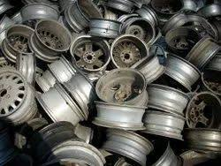

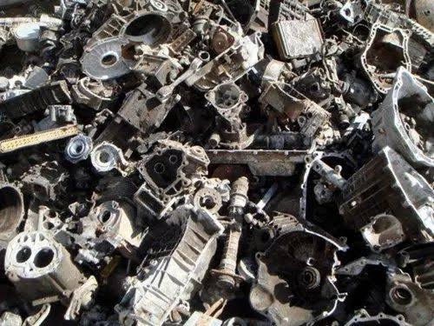

AUTOMOBILE SCRAP-TENSE/PURJA/ZORBA ALLOY WHEELS

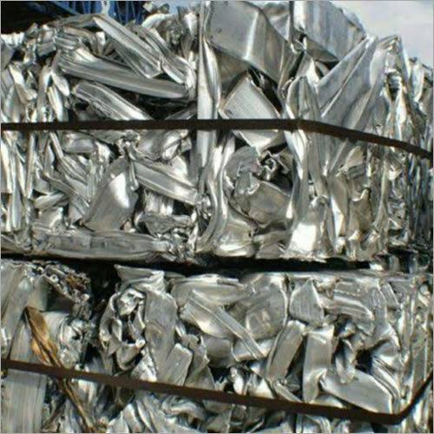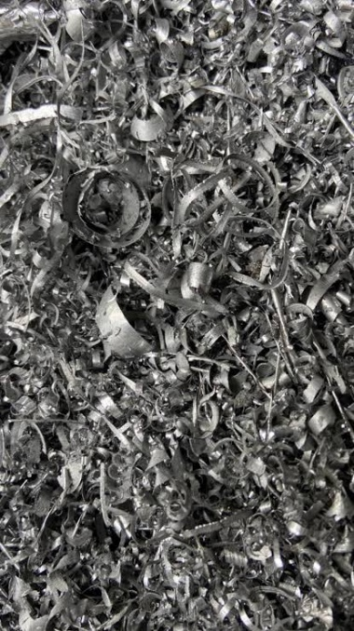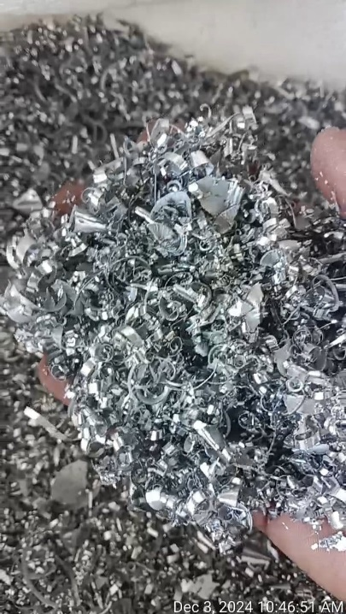

CHANNELS/ EXTRUSION TUNRING/BORING SCRAP